**Fundamental NMR Theory**

Nuclear magnetic resonance, or NMR, is a phenomenon which occurs when the nuclei of certain atoms are immersed in a static magnetic field and exposed to a second oscillating magnetic field. Some nuclei experience this phenomenon, and others do not, dependent upon whether they possess a property called spin.

Most of the matter you can examine with NMR is composed of molecules. Molecules are composed of atoms. If we zoom into one of the hydrogens, we see a nucleus composed of a single proton. The proton possesses a property called spin which can be thought of as a small magnetic field, and will cause the nucleus to produce an NMR signal.

**Spectroscopy**

Spectroscopy is the study of the interaction of electromagnetic radiation with matter. Nuclear magnetic resonance spectroscopy is the use of the NMR phenomenon to study physical, chemical, and biological properties of matter. As a consequence, NMR spectroscopy finds applications in several areas of science. NMR spectroscopy is routinely used by chemists to study chemical structure. Time domain NMR spectroscopic techniques are used to probe molecular dynamics in solutions. Solid state NMR spectroscopy is used to determine the molecular structure of solids.

**Units Review**

Before you can begin learning about NMR spectroscopy, you must be versed in the language of NMR. Please review these units before advancing to subsequent chapters in this text.

Units of time are seconds (s).

Angles are reported in degrees (o) and in radians (rad). There are 2http://www.cis.rit.edu/htbooks/nmr/images/10-pi.gif radians in 360o.

Magnetic field strength (B) is measured in Tesla (T). The earth's magnetic field in Rochester, New York is approximately 5x10-5 T.

The unit of energy (E) is the Joule (J).

The frequency of electromagnetic radiation may be reported in cycles per second or radians per second. Frequency in cycles per second (Hz) have units of inverse seconds (s-1) and are given the symbols http://www.cis.rit.edu/htbooks/nmr/images/10-nu.gif or f. Frequencies represented in radians per second (rad/s) are given the symbolhttp://www.cis.rit.edu/htbooks/nmr/images/10-omega.gif. The conversion between Hz and rad/s is easy to remember. There are 2http://www.cis.rit.edu/htbooks/nmr/images/10-pi.gif radians in a circle or cycle, therefore 2http://www.cis.rit.edu/htbooks/nmr/images/10-pi.gif rad/s = 1 Hz = 1 s-1.

Power is the energy consumed per time and has units of Watts (W).

Finally, it is common to use prefixes before units to indicate a power of ten. For example, 0.005 seconds can be written as 5x10-3 s or as 5 ms. The m implies 10-3.

**The Mathematics of NMR**

*Imaginary Numbers*

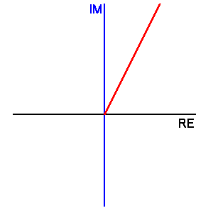A complex number is one which has a real (RE) and an imaginary (IM) part. The real and imaginary parts of a complex number are orthogonal.

Two useful relations between complex numbers and exponentials are

e+ix = cos(x) +*i*sin(x)

and

e-ix = cos(x) -*i*sin(x).

*Fourier Transforms*

The Fourier transform (FT) is a mathematical technique for converting time domain data to frequency domain data, and vice versa. An inverse Fourier transform (IFT) converts from the frequency domain to the time domain.

An FT is defined by the integral

http://www.cis.rit.edu/htbooks/nmr/chap-5/images/ft_eq_1.gif

http://www.cis.rit.edu/htbooks/nmr/chap-5/images/ft_eq_3.gifThis is easy to picture by looking at the real part of *f*(http://www.cis.rit.edu/htbooks/nmr/images/10-omega.gif) only.

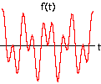

Consider the function of time, f( t ) = cos( 4t ) + cos( 9t )

To understand the FT, examine the product of f(t) with cos(http://www.cis.rit.edu/htbooks/nmr/images/10-omega.gift) for http://www.cis.rit.edu/htbooks/nmr/images/10-omega.gif values between 1 and 10, and then the summation of the values of this product between 1 and 10 seconds. The summation will only be examined for time values between 0 and 10 seconds.

http://www.cis.rit.edu/htbooks/nmr/chap-5/images/fun-w.gif

*Phase Correction*

The actual FT will make use of an input consisting of a REAL and an IMAGINARY part. You can think of Mx as the REAL input, and My as the IMAGINARY input. The resultant output of the FT will therefore have a REAL and an IMAGINARY component, too.

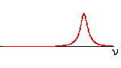Consider the following function: f (t) = e-at e-i2t

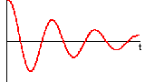

MX (Real)

http://www.cis.rit.edu/htbooks/nmr/chap-5/images/ft-box-h.gif

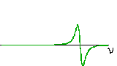

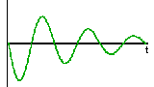

MY (Imaginary)

http://www.cis.rit.edu/htbooks/nmr/images/50-space.gif

In FT NMR spectroscopy, the real output of the FT is taken as the frequency domain spectrum. To see an esthetically pleasing (absorption) frequency domain spectrum, we want to input a cosine function into the real part and a sine function into the imaginary parts of the FT. This is what happens if the cosine part is input as the imaginary and the sine as the real.

In practice, during a real NMR experiment a phase correction must be applied to either the time or frequency domain spectra to obtain an absorption spectrum as the real output of the FT.

If the above mentioned FID is recorded such that there is a 45o phase shift in the real and imaginary FIDs, the coordinate transformation matrix can be used with http://www.cis.rit.edu/htbooks/nmr/images/12-phi.gif= - 45o. The corrected FIDs look like a cosine function in the real and a sine in the imaginary. Fourier transforming the phase corrected FIDs gives an absorption spectrum for the real output of the FT.

The phase shift also varies with frequency, so the NMR spectra require both constant and linear corrections to the phasing of the Fourier transformed signal.

http://www.cis.rit.edu/htbooks/nmr/images/12-phi.gif= m  + b

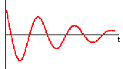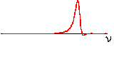

MX (Real)

http://www.cis.rit.edu/htbooks/nmr/chap-5/images/ft-box-h.gif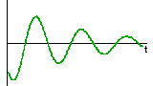

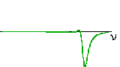

MY (Imaginary)

http://www.cis.rit.edu/htbooks/nmr/images/50-space.gif

Constant phase corrections, b, arise from the inability of the spectrometer to detect the exact Mx and My. Linear phase corrections, m, arise from the inability of the spectrometer to detect transverse magnetization starting immediately after the RF pulse. The following drawing depicts the greater loss of phase in a high frequency FID when the initial yellow section is lost. From the practical point of view, the phase correction is applied in the frequency domain rather than in the time domain because we know that a real frequency domain spectrum should be composed of all positive peaks. We can therefore adjust b and m until all positive peaks are seen in the real output of the Fourier transform.

In magnetic resonance, the Mx or My signals are displayed. A magnitude signal might occasionally be used in some applications. The magnitude signal is equal to the square root of the sum of the squares of Mx and My.

**Spin**

What is spin? Spin is a fundamental property of nature like electrical charge or mass. Spin comes in multiples of 1/2 and can be + or -. In the deuterium atom ( 2H ), with one unpaired electron, one unpaired proton, and one unpaired neutron, the total electronic spin = 1/2 and the total nuclear spin = 1.

*Properties of Spin*

When placed in a magnetic field of strength B, a particle with a net spin can absorb a photon, of frequency ν. The frequency ν depends on the gyro-magnetic ratio, γ of the particle.

ν = γ B For hydrogen, γ = 42.58 MHz / T.

*Nuclei with Spin*

The shell model for the nucleus tells us that nucleons, just like electrons, fill orbitals. When the number of protons or neutrons equals 2, 8, 20, 28, 50, 82, and 126, orbitals are filled. Because nucleons have spin, just like electrons do, their spin can pair up when the orbitals are being filled and cancel out. Almost every element in the periodic table has an isotope with a non zero nuclear spin. NMR can only be performed on isotopes whose natural abundance is high enough to be detected. Some of the nuclei routinely used in NMR are listed below.

|  |  |  |  |  |
| --- | --- | --- | --- | --- |
| **Nuclei** | **Unpaired Protons** | **Unpaired Neutrons** | **Net Spin** | **γ (MHz/T)** |
| 1H | 1 | 0 | 1/2 | 42.58 |
| 2H | 1 | 1 | 1 | 6.54 |
| 31P | 1 | 0 | 1/2 | 17.25 |
| 23Na | 1 | 2 | 3/2 | 11.27 |
| 14N | 1 | 1 | 1 | 3.08 |
| 13C | 0 | 1 | 1/2 | 10.71 |
| 19F | 1 | 0 | 1/2 | 40.08 |

*Energy Levels*

To understand how particles with spin behave in a magnetic field, consider a proton. This proton has the property called spin. Think of the spin of this proton as a magnetic moment vector, causing the proton to behave like a tiny magnet with a north and south pole.

When the proton is placed in an external magnetic field, the spin vector of the particle aligns itself with the external field, just like a magnet would. There is a low energy configuration or state where the poles are aligned N-S-N-S and a high energy state N-N-S-S.

With no magnetic field, magnetic moments are random. In Strong Magnetic Field (Bo), magnetic moments align along Bo

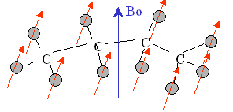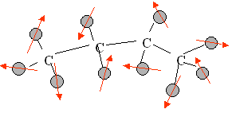

*Transitions*

This particle can undergo a transition between the two energy states by the absorption of a photon. A particle in the lower energy state absorbs a photon and ends up in the upper energy state. The energy of this photon must exactly match the energy difference between the two states. The energy, E, of a photon is related to its frequency, ν, by Planck's constant (6.626x10-34 J s).

E = h ν

In NMR and MRI, the quantity ν is called the resonance frequency and the Larmor frequency.

*Energy Level Diagrams*

The energy of the two spin states can be represented by an energy level diagram. We have seen that ν = γ B and E = h ν, therefore the energy of the photon needed to cause a transition between the two spin states is

E = h γ B

When the energy of the photon matches the energy difference between the two spin states absorption of energy occurs. In the NMR experiment, the frequency of the photon is in the radio frequency (RF) range. In NMR spectroscopy, ν is between 20 and 800 MHz for hydrogen nuclei. In clinical MRI, ν is typically between 15 and 80 MHz for hydrogen imaging.

*CW NMR Experiment*

The simplest NMR experiment is the continuous wave (CW) experiment. The CW experiment can be performed with a constant magnetic field and a frequency which is varied. The magnitude of the constant magnetic field is represented by the position of the vertical blue line in the energy level diagram.



*Boltzmann Statistics*

When a group of spins is placed in a magnetic field, each spin aligns in one of the two possible orientations. At room temperature, the number of spins in the lower energy level, N+, slightly outnumbers the number in the upper level, N-.

Boltzmann statistics tells us that N-/N+ = e-E/kT.

E is the energy difference between the spin states; k is Boltzmann's constant, 1.3805x10-23 J/Kelvin; and T is the temperature in Kelvin. As the temperature decreases, so does the ratio N- /N+. As the temperature increases, the ratio approaches one.

The signal in NMR spectroscopy results from the difference between the energy absorbed by the spins which make a transition from the lower energy state to the higher energy state, and the energy emitted by the spins which simultaneously make a transition from the higher energy state to the lower energy state. The signal is thus proportional to the population difference between the states. NMR is a rather sensitive spectroscopy since it is capable of detecting these very small population differences. It is the resonance, or exchange of energy at a specific frequency between the spins and the spectrometer, which gives NMR its sensitivity.

*Magnetic Moment*

Precessing Spins can be described as a Bulk Magnetic Moment Mo (Summation of Individual Magnetic Moments).The size of the Magnetic vector is proportional to (N+ - N-). In order to describe pulsed NMR is necessary from here on to talk in terms of the net magnetization.

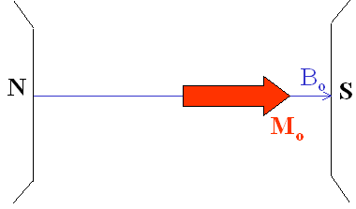

Adapting the conventional NMR coordinate system, the external magnetic field and the net magnetization vector at equilibrium are both along the Z axis.

*T1 Processes*

At equilibrium, the net magnetization vector lies along the direction of the applied magnetic field Bo and is called the equilibrium magnetization Mo. In this configuration, the Z component of magnetization MZ equals Mo. MZ is referred to as the longitudinal magnetization. There is no transverse (MX or MY) magnetization here.

It is possible to change the net magnetization by exposing the nuclear spin system to energy of a frequency equal to the energy difference between the spin states. If enough energy is put into the system, it is possible to saturate the spin system and make MZ=0.

The time constant which describes how MZ returns to its equilibrium value is called the spin lattice relaxation time (T1). The equation governing this behavior as a function of the time t after its displacement is:

Mz = Mo (1 - e-t/T1 )

The spin-lattice relaxation time (T1) is the time to reduce the difference between the longitudinal magnetization (MZ) and its equilibrium value by a factor of e.

*Precession*

If the net magnetization is placed in the XY plane it will rotate about the Z axis at a frequency equal to the frequency of the photon which would cause a transition between the two energy levels of the spin. This frequency is called the Larmor frequency.

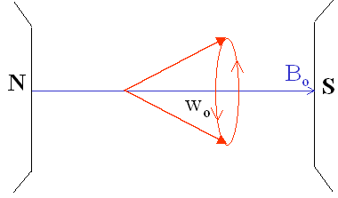

*T2 Processes*

In addition to the rotation, the net magnetization starts to de-phase because each of the spin packets making it up is experiencing a slightly different magnetic field and rotates at its own Larmor frequency. The longer the elapsed time, the greater the phase difference. Here the net magnetization vector is initially along +Y. For this and all de-phasing examples think of this vector as the overlap of several thinner vectors from the individual spin packets.



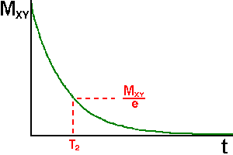The time constant which describes the return to equilibrium of the transverse magnetization, MXY, is called the spin-spin relaxation time, T2.

MXY =MXYo e-t/T2

T2 is always less than or equal to T1. The net magnetization in the XY plane goes to zero and then the longitudinal magnetization grows in until we have Mo along Z. Actually, both processes occur simultaneously.

Any transverse magnetization behaves the same way. The transverse component rotates about the direction of applied magnetization and de-phases. T1 governs the rate of recovery of the longitudinal magnetization.

Two factors contribute to the decay of transverse magnetization:  
1) Molecular interactions (said to lead to a pure *T2* molecular effect)   
2) Variations in Bo (said to lead to an *inhomogeneous T2* effect)  
The combination of these two factors is what actually results in the decay of transverse magnetization. The combined time constant is called T2 star and is given the symbol T2*. The relationship between the T2 from molecular processes and that from in-homogeneities in the magnetic field is as follows.

1/T2* = 1/T2 + 1/T2inhomo.

*Rotating Frame of Reference*

We have just looked at the behavior of spins in the laboratory frame of reference. It is convenient to define a rotating frame of reference which rotates about the Z axis at the Larmor frequency.

A magnetization vector rotating at the Larmor frequency in the laboratory frame appears stationary in a frame of reference rotating about the Z axis. In the rotating frame, relaxation of MZ magnetization to its equilibrium value looks the same as it did in the laboratory frame.

A transverse magnetization vector rotating about the Z axis at the same velocity as the rotating frame will appear stationary in the rotating frame. A magnetization vector traveling faster than the rotating frame rotates clockwise about the Z axis. A magnetization vector traveling slower than the rotating frame rotates counter-clockwise about the Z axis .

In a sample there are spin packets traveling faster and slower than the rotating frame. As a consequence, when the mean frequency of the sample is equal to the rotating frame, the de-phasing of MX'Y' looks like this.

*Pulsed Magnetic Fields*

A coil of wire placed around the X axis will provide a magnetic field along the X axis when a direct current is passed through the coil. An alternating current will produce a magnetic field which alternates in direction.

In a frame of reference rotating about the Z axis at a frequency equal to that of the alternating current, the magnetic field along the X' axis will be constant, just as in the direct current case in the laboratory frame.

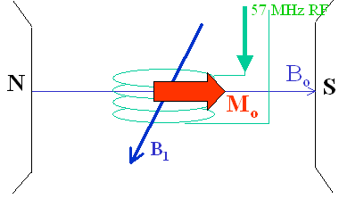

This is the same as moving the coil about the rotating frame coordinate system at the Larmor Frequency. In magnetic resonance, the magnetic field created by the coil passing an alternating current at the Larmor frequency is called the B1 magnetic field. When the alternating current through the coil is turned on and off, it creates a pulsed B1 magnetic field along the X' axis.

The spins respond to this pulse in such a way as to cause the net magnetization vector to rotate about the direction of the applied B1 field. The rotation angle depends on the length of time the field is on, τ, and its magnitude B1.

θ = 2π γ τ B1.

In our examples, τ will be assumed to be much smaller than T1 and T2.

A 90o pulse is one which rotates the magnetization vector clockwise by 90 degrees about the X' axis. A 90o pulse rotates the equilibrium magnetization down to the Y' axis. In the laboratory frame the equilibrium magnetization spirals down around the Z axis to the XY plane. You can see why the rotating frame of reference is helpful in describing the behavior of magnetization in response to a pulsed magnetic field.

A 180o pulse will rotate the magnetization vector by 180 degrees. A 180o pulse rotates the equilibrium magnetization down to along the -Z axis.

The net magnetization at any orientation will behave according to the rotation equation. For example, a net magnetization vector along the Y' axis will end up along the -Y' axis when acted upon by a 180o pulse of B1 along the X' axis.

A net magnetization vector between X' and Y' will end up between X' and -Y' after the application of a 180o pulse of B1 applied along the X' axis.

**Spin Relaxation**

Motions in solution which result in time varying magnetic fields cause spin relaxation.

Time varying fields at the Larmor frequency cause transitions between the spin states and hence a change in MZ. This screen depicts the field at the green hydrogen on the water molecule as it rotates about the external field Bo and a magnetic field from the blue hydrogen.

There is a distribution of rotation frequencies in a sample of molecules. Only frequencies at the Larmor frequency affect T1. Since the Larmor frequency is proportional to Bo, T1 will therefore vary as a function of magnetic field strength. In general, T1 is inversely proportional to the density of molecular motions at the Larmor frequency.

The rotation frequency distribution depends on the temperature and viscosity of the solution. Therefore T1 will vary as a function of temperature. At the Larmor frequency indicated by νo, T1 (280 K ) < T1 (340 K). The temperature of the human body does not vary by enough to cause a significant influence on T1. The viscosity does however vary significantly from tissue to tissue and influences T1 as is seen in the following molecular motion plot.

Fluctuating fields which perturb the energy levels of the spin states cause the transverse magnetization to de-phase. The number of molecular motions less than and equal to the Larmor frequency is inversely proportional to T2.

In general, relaxation times get longer as Bo increases because there is fewer relaxation-causing frequency components present in the random motions of the molecules.

**NMR SPECTROSCOPY**

### Chemical Shift

When an atom is laced in a magnetic field, its electrons circulate about the direction of the applied magnetic field. This circulation causes a small magnetic field at the nucleus which opposes the externally applied field.



The magnetic field at the nucleus (the effective field) is therefore generally less than the applied field by a fractionhttp://www.cis.rit.edu/htbooks/nmr/images/10-sigma.gif.

B = Bo (1-)

The electron density around each nucleus in a molecule varies according to the types of nuclei and bonds in the molecule. The opposing field and therefore the effective field at each nucleus will vary. This is called the chemical shift phenomenon.

Consider the methanol molecule. The resonance frequency of two types of nuclei in this example differs. This difference will depend on the strength of the magnetic field, Bo, used to perform the NMR spectroscopy.

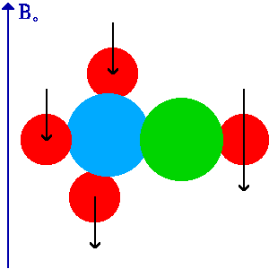

The greater the value of Bo, the greater the frequency difference. This relationship could make it difficult to compare NMR spectra taken on spectrometers operating at different field strengths. The term chemical shift was developed to avoid this problem.

The chemical shift of a nucleus is the difference between the resonance frequency of the nucleus and a standard, relative to the standard. This quantity is reported in ppm and given the symbol delta,http://www.cis.rit.edu/htbooks/nmr/images/10-delta.gif.

 = ( - REF) x106 / REF

In NMR spectroscopy, this standard is often tetramethylsilane, Si(CH3)4, abbreviated TMS. The chemical shift is a very precise metric of the chemical environment around a nucleus. For example, the hydrogen chemical shift of CH2 hydrogen next to a Cl will be different than that of a CH3 next to the same Cl. It is therefore difficult to give a detailed list of chemical shifts in a limited space. The animation window displays a chart of selected hydrogen chemical shifts of pure liquids and some gasses.

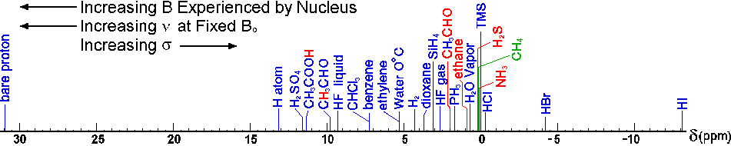

The magnitude of the screening depends on the atom. For example, carbon-13 chemical shifts are much greater than hydrogen-1 chemical shifts. The following tables present selected chemical shifts of fluorine-19 containing compounds. These shifts are all relative to the bare nucleus.

Fluorine-19 Chemical Shifts [http://www.cis.rit.edu/htbooks/nmr/images/ref.gif](http://www.cis.rit.edu/htbooks/nmr/refs/ref-05.htm)

|  |  |
| --- | --- |
| **Fluorine-19  Environment** | **Chemical Shift Range (ppm)** |
| UF6 | -540 |
| FNO | -269 |
| F2 | -210 |
| bare nucleus | 0 |
| C(CF3)4 | 284 |
| CF3(COOH) | 297 |
| fluorobenzene | 333 |
| F- | 338 |
| BF3 | 345 |
| HF | 415 |

### Spin-Spin Coupling

Nuclei experiencing the same chemical environment or chemical shift are called equivalent. Those nuclei experiencing different environment or having different chemical shifts are nonequivalent. Nuclei which are close to one another exert an influence on each other's effective magnetic field. This effect shows up in the NMR spectrum when the nuclei are nonequivalent. If the distance between non-equivalent nuclei is less than or equal to three bond lengths, this effect is observable. This effect is called spin-spin coupling or J coupling.

Consider the following example. There are two nuclei, A and B, three bonds away from one another in a molecule.

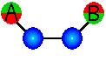

The spin of each nucleus can be either aligned with the external field such that the fields are N-S-N-S, called spin up http://www.cis.rit.edu/htbooks/nmr/images/12-up.gif, or opposed to the external field such that the fields are N-N-S-S, called spin down http://www.cis.rit.edu/htbooks/nmr/images/12-down.gif. The magnetic field at nucleus A will be either greater than Bo or less than Bo by a constant amount due to the influence of nucleus B.

There are a total of four possible configurations for the two nuclei in a magnetic field. Arranging these configurations in order of increasing energy gives the following arrangement.

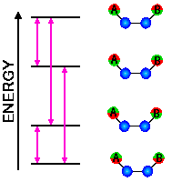

The vertical lines in this diagram represent the allowed transitions between energy levels. In NMR, an allowed transition is one where the spin of one nucleus changes from spin up http://www.cis.rit.edu/htbooks/nmr/images/12-up.gifto spin downhttp://www.cis.rit.edu/htbooks/nmr/images/12-down.gif, or spin down http://www.cis.rit.edu/htbooks/nmr/images/12-down.gifto spin uphttp://www.cis.rit.edu/htbooks/nmr/images/12-up.gif. Absorptions of energy where two or more nuclei change spin at the same time are not allowed. There are two absorption frequencies for the A nucleus and two for the B nucleus represented by the vertical lines between the energy levels in this diagram.

The NMR spectrum for nuclei A and B reflects the splitting observed in the energy level diagram. The A absorption line is split into 2 absorption lines centered on http://www.cis.rit.edu/htbooks/nmr/images/10-delta.gifA, and the B absorption line is split into 2 lines centered on http://www.cis.rit.edu/htbooks/nmr/images/10-delta.gifB. The distance between two split absorption lines is called the J coupling constant or the spin-spin splitting constant and is a measure of the magnetic interaction between two nuclei.

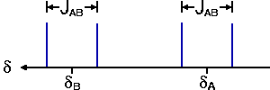

The complexity of the splitting pattern in a spectrum increases as the number of B nuclei increases.

### 

### The Time Domain NMR Signal

An NMR sample may contain many different magnetization components, each with its own Larmor frequency. These magnetization components are associated with the nuclear spin configurations joined by an allowed transition line in the energy level diagram. Based on the number of allowed absorptions due to chemical shifts and spin-spin couplings of the different nuclei in a molecule, an NMR spectrum may contain many different frequency lines.

In pulsed NMR spectroscopy, signal is detected after these magnetization vectors are rotated into the XY plane. Once a magnetization vector is in the XY plane it rotates about the direction of the Bo field, the +Z axis. As transverse magnetization rotates about the Z axis, it will induce a current in a coil of wire located around the X axis.

http://www.cis.rit.edu/htbooks/nmr/chap-3/images/x-c-rf.gifhttp://www.cis.rit.edu/htbooks/nmr/chap-3/images/y-lab.gif

Plotting current as a function of time gives a sine wave.

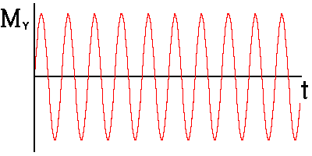

This wave will, of course, decay with time constant T2* due to de-phasing of the spin packets. This signal is called free induction decay (FID.

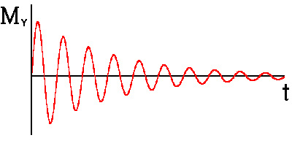

### 

### The +/- Frequency Convention

Transverse magnetization vectors rotating faster than the rotating frame of reference are said to be rotating at a positive frequency relative to the rotating frame (+n). Vectors rotating slower than the rotating frame are said to be rotating at a negative frequency relative to the rotating frame (-n).

It is worthwhile noting here that in most NMR spectra, the resonance frequency of a nucleus, as well as the magnetic field experienced by the nucleus and the chemical shift of a nucleus, increase from right to left. The frequency plots used in this hypertext book to describe Fourier transforms will use the more conventional mathematical axis of frequency increasing from left to right.

**PULSE SEQUENCES**

### Introduction

You have seen how a time domain signal can be converted into a frequency domain signal. In this chapter you will learn a few of the ways that a time domain signal can be created. Three methods are presented here, but there are an infinite number of possibilities. These methods are called pulse sequences. A pulse sequence is a set of RF pulses applied to a sample to produce a specific form of NMR signal.

### The 90-FID Sequence

In the 90-FID pulse sequence, net magnetization is rotated down into the X'Y' plane with a 90° pulse. The net magnetization vector begins to precess about the +Z axis. The magnitude of the vector also decays with time.

http://www.cis.rit.edu/htbooks/nmr/chap-3/images/x-p-b1.gif

A timing diagram is a multiple axis plot of some aspect of a pulse sequence versus time. A timing diagram for a 90°-FID pulse sequence has a plot of RF energy versus time and another for signal versus time.

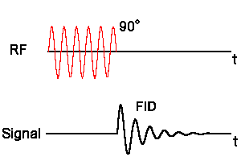

When this sequence is repeated, for example when signal-to-noise improvement is needed, the amplitude of the signal after being Fourier transformed (S) will depend on T1 and the time between repetitions, called the repetition time (TR), of the sequence. In the signal equation below, k is proportionality constant and http://www.cis.rit.edu/htbooks/nmr/images/10-rho.gif is the density of spins in the sample.

S = k http://www.cis.rit.edu/htbooks/nmr/images/10-rho.gif( 1 - e-TR/T1 )

### The Spin-Echo Sequence

Another commonly used pulse sequence is the spin-echo pulse sequence. Here a 90° pulse is first applied to the spin system. The 90° degree pulse rotates the magnetization down into the X'Y' plane. The transverse magnetization begins to de-phase.

http://www.cis.rit.edu/htbooks/nmr/chap-3/images/x-prime.gifhttp://www.cis.rit.edu/htbooks/nmr/chap-3/images/y-prime.gif

At some point in time after the 90° pulse, a 180° pulse is applied. This pulse rotates the magnetization by 180° about the X' axis. The 180° pulse causes the magnetization to at least partially re-phase and to produce a signal called an echo.

http://www.cis.rit.edu/htbooks/nmr/chap-3/images/x-prime.gifhttp://www.cis.rit.edu/htbooks/nmr/chap-3/images/y-prime.gif

A timing diagram shows the relative positions of the two radio frequency pulses and the signal.

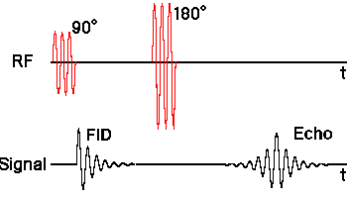

The signal equation for a repeated spin echo sequence as a function of the repetition time, TR, and the echo time (TE) defined as the time between the 90o pulse and the maximum amplitude in the echo is

S = k http://www.cis.rit.edu/htbooks/nmr/images/10-rho.gif( 1 - e-TR/T1 ) e-TE/T2

**NMR HARDWARE**

### Hardware Overview

The graphics window displays a schematic representation of the major systems of a nuclear magnetic resonance spectrometer and a few of the major interconnections. This overview briefly states the function of each component.

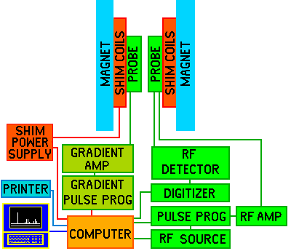

The magnet produces the Bo field necessary for the NMR experiments. Immediately within the bore of the magnet are the shim coils for homogenizing the Bo field. Within the shim coils is the probe. The probe contains the RF coils for producing the B1 magnetic field necessary to rotate the spins by 90o or 180o. The RF coil also detects the signal from the spins within the sample. The sample is positioned within the RF coil of the probe. Some probes also contain a set of gradient coils. These coils produce a gradient in Bo along the X, Y, or Z axis. Gradient coils are used for enhanced the homogeny of the magnet.

The heart of the spectrometer is the computer. It controls all of the components of the spectrometer. The RF components under control of the computer are the RF frequency source and pulse programmer. The source produces a sine wave of the desired frequency. The pulse programmer sets the width, and in some cases the shape, of the RF pulses. The RF amplifier increases the pulses power from milli-Watts to tens of Watts. The computer also controls the gradient pulse programmer which sets the shape and amplitude of the magnetic fields. The gradient amplifier increases the power of the gradient to a level sufficient to drive the gradient coils.

The operator of the spectrometer gives input to the computer through a console terminal with a mouse and keyboard and also has a separate interface for carrying out some of the more routine procedures on the spectrometer. A pulse sequence is selected and customized from the console terminal. The operator can see spectra on a video display located on the console and can make hard copies of spectra using a printer.

### Magnet

The NMR magnet is arguably the most important part of the NMR spectrometer. The NMR magnet is one of the most expensive components of the nuclear magnetic resonance spectrometer system. NMR magnet technology has evolved considerably since the development of NMR. Early NMR magnets were iron core permanent or electromagnets producing magnetic fields of less than 1.5 T. Today, most NMR magnets are of the superconducting type. Superconducting NMR magnets range in field strength from approximately 6 to 23.5 T.

The magnet is a permanent magnet built from multiple segments of neodymium boron iron. This material is used because it’s very high field strength-to-mass ratio achieves the desired flux density in a small, compact package. Because the flux must be extremely uniform over the entire air gap, construction of the magnet is complex. The magnet is fabricated from several segments bonded together to form the basic assembly. In addition to the magnetic material, there is SHIM cassette which inserted into the magnet and contains 48 coils of wire located in the center of the magnet between the pole pieces. These coils are used as small electromagnets, the strength and polarity of which can be controlled by varying the current through them so as to improve uniformity of the overall field of the magnet assembly. This adjustment process, called “shimming”.

A manual shimming procedure, performed at initial installation, mechanically aligns the faces of the magnet pole pieces to an optimum position. This operation is performed by adjusting pairs of adjusting screws at the outside ends of the magnet housing. This operation is required only after shipping or relocating the magnet which might subject it to rough movement.

Prior to assembly in the manufacturing plant, the absolute field strength of each individual segment of the magnet is measured. A computer analysis of this data then determines the best placement of each segment in the final assembly to achieve a consistent, uniform field for the assembled magnet. The segments are then assembly together to form the final magnet construction.

The assembly is placed inside a soft iron box that constrains the magnetic flux and prevents the magnetic field outside the magnet housing from exceeding a value of as little as 1 gauss. More importantly, the iron box raises field strength in the center of the magnet by pushing the flux toward the center, a process called “condensing the field”.

Since temperature of the magnet and sample must be so tightly controlled to achieve the desired accuracy of measurement, a set of Thermistors are mounted at various points on the magnet to sense magnet temperature. A heater control unit receives temperature measurement information from the Thermistors and regulates current to several resistance heating strips bonded to the outside of the magnet assembly. Similarly, a set of Thermistors are bonded at various points to the magnet envelope. The Heater Controller uses the Thermistors signals as inputs to a control loop that, in turn, controls current to heaters bonded to the envelope. A complete Magnet assembly is shown below.

The control functions for these two temperature PID loops are performed by the Heater Controller. Temperature of the cover is maintained at a lower temperature than that of the magnet itself. The software that executes the control algorithms, which is supplies with the main system software, is shown as Heater in the Lab MRS.



### Shim Coils

The purpose of shim coils on a spectrometer is to correct minor spatial in-homogeneities in the Bo magnetic field. These in-homogeneities could be caused by the magnet design, materials in the probe, variations in the thickness of the sample tube, sample permeability, and ferromagnetic materials around the magnet. A shim coil is designed to create a small magnetic field which will oppose and cancel out an in-homogeneity in the Bo magnetic field. Because these variations may exist in a variety of functional forms (linear, parabolic, etc.), shim coils are needed which can create a variety of opposing fields. Some of the functional forms are listed in the table below.

Shim Coil Functional Forms

|  |  |
| --- | --- |
| Shim | Function |
| Z0 | http://www.cis.rit.edu/htbooks/nmr/chap-7/images/z0.gif |
| Z1 | http://www.cis.rit.edu/htbooks/nmr/chap-7/images/z.gif |
| Z2 | http://www.cis.rit.edu/htbooks/nmr/chap-7/images/z2.gif |
| Z3 | http://www.cis.rit.edu/htbooks/nmr/chap-7/images/z3.gif |
| XZ | http://www.cis.rit.edu/htbooks/nmr/chap-7/images/xz.gif |
| X2Y2 | http://www.cis.rit.edu/htbooks/nmr/chap-7/images/y2x2.gif |

By passing the appropriate amount of current through each coil a homogeneous Bo magnetic field can be achieved. The optimum shim current settings are found by either minimizing the line-width or maximizing the size of the FID. On most spectrometers, the shim coils are controllable by the computer. A computer algorithm has the task of finding the best shim value by maximizing the lock signal.

### Sample Probe

The sample probe is the name given to that part of the spectrometer which accepts the sample, sends RF energy into the sample, and detects the signal emanating from the sample. It contains the RF coil. The RF coil

### RF Coils

RF coils create the B1 field which rotates the net magnetization in a pulse sequence. They also detect the transverse magnetization as it precesses in the XY plane. Most RF coils on NMR spectrometers are of the saddle coil design and act as the transmitter of the B1 field and receiver of RF energy from the sample.

Each of these RF coils must resonate, that is they must efficiently store energy, at the Larmor frequency of the nucleus being examined with the NMR spectrometer. All NMR coils are composed of an inductor, or inductive elements, and a set of capacitive elements. The resonant frequency, http://www.cis.rit.edu/htbooks/nmr/images/10-nu.gif, of an RF coil is determined by the inductance (L) and capacitance (C) of the inductor capacitor circuit.

http://www.cis.rit.edu/htbooks/nmr/chap-7/images/coil-eq.gif

RF coils used in NMR spectrometers need to be tuned for the specific sample being studied. An RF coil has a bandwidth or specific range of frequencies at which it resonates. When you place a sample in an RF coil, the conductivity and dielectric constant of the sample affect the resonance frequency. If this frequency is different from the resonance frequency of the nucleus you are studying, the coil will not efficiently set up the B1 field nor efficiently detect the signal from the sample. You will be rotating the net magnetization by an angle less than 90 degrees when you think you are rotating by 90 degrees. This will produce less transverse magnetization and less signal. Furthermore, because the coil will not be efficiently detecting the signal, your signal-to-noise ratio will be poor.

The B1 field of an RF coil must be perpendicular to the Bo magnetic field. Another requirement of an RF coil in an NMR spectrometer is that the B1 field needs to be homogeneous over the volume of your sample. If it is not, you will be rotating spins by a distribution of rotation angles and you will obtain strange spectra.

### Quadrature Detector

The Quadrature detector is a device which separates out the Mx' and My' signals from the signal from the RF coil. For this reason it can be thought of as a laboratory to rotating frame of reference converter. The heart of a Quadrature detector is a device called a doubly balanced mixer. The doubly balanced mixer has two inputs and one output. If the input signals are Cos(A) and Cos(B), the output will be 1/2 Cos(A+B) and 1/2 Cos(A-B). For this reason the device is often called a product detector since the product of Cos(A) and Cos(B) is the output.

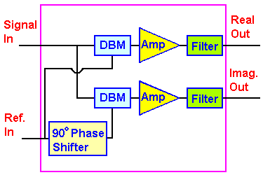

The Quadrature detector typically contains two doubly balanced mixers, two filters, two amplifiers, and a 90o phase shifter. There are two inputs and two outputs on the device. Frequency http://www.cis.rit.edu/htbooks/nmr/images/10-nu.gif and http://www.cis.rit.edu/htbooks/nmr/images/10-nu.gifo are put in and the MX' and MY' components of the transverse magnetization come out. There are some potential problems which can occur with this device which will cause artifacts in the spectrum. One is called a DC offset artifact and the other is called a Quadrature artifact.

### Digital Filtering

Many newer spectrometers employ a combination of oversampling, digital filtering, and decimation to eliminate the wrap around artifact. Oversampling creates a larger spectral or sweep width, but generates too much data to be conveniently stored. Digital filtering eliminates the high frequency components from the data, and decimation reduces the size of the data set. The following flowchart summarizes the effects of the three steps by showing the result of performing an FT after each step.

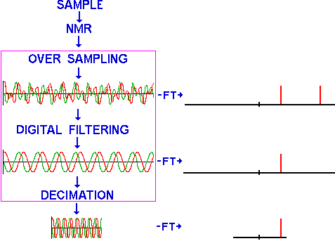

Let's examine oversampling, digital filtering, and decimation in more detail to see how this combination of steps can be used to reduce the wrap around problem.

Oversampling is the digitization of a time domain signal at a frequency much greater than necessary to record the desired spectral width. For example, if the sampling frequency, fs, is increased by a factor of 10, the sweep width will be 10 times greater, thus eliminating wraparound. Unfortunately digitizing at 10 times the speed also increases the amount of raw data by a factor of 10, thus increasing storage requirements and processing time.

Filtering is the removal of a select band of frequencies from a signal. For an example of filtering, consider the following frequency domain signal. Frequencies above fo could be removed from this frequency domain signal by multiplying the signal by this rectangular function. In NMR, this step would be equivalent to taking a large sweep width spectrum and setting to zero intensity those spectral frequencies which are farther than some distance from the center of the spectrum.

Digital filtering is the removal of these frequencies using the time domain signal. Recall from [Chapter 5](http://www.cis.rit.edu/htbooks/nmr/chap-5/chap-5.htm#5.7) that if two functions are multiplied in one domain (i.e. frequency), we must convolve the FT of the two functions together in the other domain (i.e. time). To filter out frequencies above fo from the time domain signal, the signal must be convolved with the Fourier transform of the rectangular function, a sinc function. This process eliminates frequencies greater than fo from the time domain signal. Fourier transforming the resultant time domain signal yields a frequency domain signal without the higher frequencies. In NMR, this step will remove spectral components with frequencies greater than +fo and less than -fo.

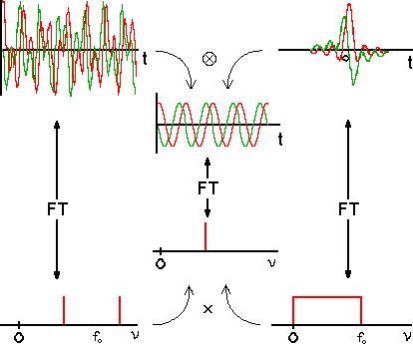

Decimation is the elimination of data points from a data set. A decimation ratio of 4/5 means that 4 out of every 5 data points are deleted, or every fifth data point is saved. Decimating the digitally filtered data above, followed by a Fourier transform, will reduce the data set by a factor of five.

High speed digitizers, capable of digitizing at 2 MHz, and dedicated high speed integrated circuits, capable of performing the convolution on the time domain data as it is being recorded, are used to realize this procedure.